KAHENI PETER

P101/1740G/21

CAT TWO

BIT 413

QUESTION 1

Required

Identify five common problems that a project manager might have to resolve and explain the impact that each of these problems would have on the project, if not managed effectively.

1. Poor Communication

Inefficient communication leads to misunderstandings about project goals, roles, or deadlines. It can result in missed deadlines, duplicated efforts, or substandard work. Stakeholders may feel uninformed or excluded, causing dissatisfaction or disengagement.

2. Scope Creep

Uncontrolled changes or expansions in project scope can strain resources, extend timelines, and inflate costs. It may also lead to a diluted focus on the original project objectives, ultimately affecting the quality of deliverables and stakeholder satisfaction.

3. Resource Constraints

Insufficient resources (budget, manpower, or tools) can slow progress or compromise quality. Key tasks may be delayed, leading to missed milestones, project delays, or an inability to meet client expectations.

4. Risk Mismanagement

Ignoring or inadequately managing risks can lead to unexpected issues like budget overruns, delays, or even project failure. For example, technical challenges or external factors like market changes could derail the project without contingency plans.

5. Team Conflicts

Disputes among team members can harm morale, reduce collaboration, and lower productivity. Persistent conflicts may lead to a toxic work environment, high turnover rates, and decreased project efficiency.

b) Consider the following network for a small maintenance project (all times are in days)

Required:

i. Draw a Network diagram for the project and identify the critical path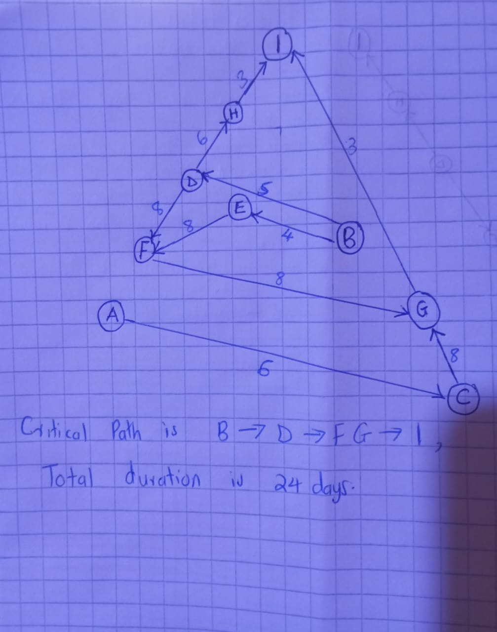

QUESTION 2

1. You have been employed as an independent consultant by an organisation that has suffered a

series of major project failures. Your investigations reveal that the main reason for these failures has been a lack of a formal project management methodology.

Discuss the reasons why a formal project management methodology should be used.

* Consistency: Ensures all team members follow the same procedures.
* Accountability: Clearly defined roles make accountability straightforward.
* Risk Management: Proactive identification and mitigation of risks.
* Efficiency: Reduces redundancies and improves resource utilization.
* Scalability: Adapts to projects of different sizes and complexities.

1. Describe project integration management and its relationship to the other eight Project Management Body of Knowledge areas.
2. Processes of Project Integration Management

**Develop Project Charter:**

Formal authorization of the project and initial identification of objectives, stakeholders, and scope.

**Develop Project Management Plan:**

Combining all subsidiary plans (e.g., scope, schedule, cost) into a single, unified plan

**Direct and Manage Project Work**

Executing project activities to produce deliverables.

**Manage Project Knowledge:**

Capturing and sharing lessons learned to improve outcomes.

**Monitor and Control Project Work:**

Tracking performance and progress to ensure alignment with the plan.

**Perform Integrated Change Control:**

Managing changes to project scope, schedule, and budget systematically.

**Close Project or Phase:**

Finalizing all activities to formally complete the project or a project phase.

ii) Relationship to the Other Eight PMBOK Knowledge Areas

Project Scope Management

Integration ensures that the project's scope is defined, controlled, and aligned with organizational goals.

It prevents scope creep by coordinating scope changes with overall project objectives.

Project Schedule Management

Integration balances time constraints and aligns scheduling with resource availability.

It consolidates schedules into the master plan, ensuring dependencies and milestones are coordinated.

Project Cost Management

Integration ensures cost estimates and budgets are aligned with the project’s goals and any financial changes are approved and reflected in the overall plan.

Project Quality Management

Integration aligns quality objectives with project deliverables and ensures they are met through coordination across teams and processes.

Project Resource Management

Ensures resource allocation is optimized and integrated into the project plan, balancing team workloads and preventing over allocation.

Project Communications Management

Integration ensures consistent and timely communication across stakeholders to keep everyone informed and engaged.

Project Risk Management

Integration incorporates risk mitigation strategies into the overall plan, ensuring that risks are identified, monitored, and addressed holistically.

Project Procurement Management

Integration ensures procurement processes are aligned with project timelines, budgets, and deliverables, managing contracts and vendor relations effectively.

Project Stakeholder Management

Integration aligns stakeholder engagement with the project objectives, ensuring that their needs and expectations are managed throughout the project lifecycle.

QUESTION 3

a) The development of information systems inevitably involves an element of risk. Three factors often used in risk analysis in the context of developing information systems are project size, project structure and technology level.

Required:

1. Briefly discuss how each of the three factors: project size, project structure and technology level can be assessed in the context of developing information systems. [6 Marks]

Project Size

* + Team Size: Larger teams may face coordination challenges, increasing risks of miscommunication and delays.
  + Budget: High-budget projects have greater financial stakes, making risk management crucial.
  + Timeline: Longer projects are more susceptible to changing requirements, market conditions, or resource availability.
  + Scope: A broader scope increases complexity, requiring more effort to manage dependencies and deliverables

Project Structure

* + Clarity of Objectives: Poorly defined goals or ambiguous requirements create uncertainty.
  + Stakeholder Involvement: Lack of active stakeholder engagement may lead to unmet expectations.
  + Processes and Documentation: A well-structured project has clear workflows, defined milestones, and comprehensive documentation.

Technology Level

* + Maturity of Technology: Established technologies are less risky, while emerging technologies may lack documentation or experienced personnel.
  + Team Expertise: The availability of skilled developers and familiarity with the technology impacts feasibility.
  + Integration Complexity: Compatibility with existing systems and platforms can increase risk.
    1. Briefly evaluate the use of a project risk analysis using the three factors

• Strengths

* Comprehensive Understanding: Assessing size, structure, and technology provides a well-rounded perspective on potential risks.
* Proactive Risk Management: Identifying these factors early allows for the development of mitigation strategies, such as resource allocation, better planning, or adopting alternative technologies.
* Prioritization: Helps prioritize high-risk areas, focusing efforts and resources where they are most needed.

• Limitations

* Subjectivity: The assessment of these factors may rely heavily on subjective judgments, leading to inconsistencies.
* Incomplete Analysis: These three factors do not account for external risks (e.g., regulatory changes, market dynamics) or human factors like team morale.
* Dynamic Nature of Risks: Risks evolve over time, and static analysis at the start of the project may not address emerging challenges.

1. Risk avoidance and contingency planning are two methods used by a project manager to reduce project risk. Compare these two methods and describe the circumstances in which each of them could be effective.
   1. Comparison of risk avoidance and contingency

|  |  |  |
| --- | --- | --- |
| Aspect | Risk Avoidance | Contingency Planning |
| Definition | Eliminating potential risks by altering project plans, scope, or approach. | Preparing for risks by creating alternative plans or measures to address issues if they occur. |
| Approach | Proactive: Focuses on avoiding the risk entirely. | Reactive: Focuses on responding to risks when they occur |
| Timing | Applied during the project planning phase to eliminate risks before they materialize. | Applied during planning and execution phases to address anticipated risks. |
| Examples | - Simplifying project scope. - Using proven technologies instead of experimental ones. - Avoiding risky vendors or partners. | - Allocating extra budget or time as buffers. - Having backup systems or resources. - Creating detailed action plans for known risks. |
| Impact on Project | Reduces complexity or changes project characteristics to avoid risk but may limit opportunities. | Ensures preparedness, minimizing the impact of risks without altering project characteristics significantly. |

* 1. Circumstances for effectiveness of risk avoidance and contingency planning

**Risk avoidance**

* + The risk has a high likelihood and severe impact, making it unacceptable.
  + Alternative strategies or solutions are available that do not compromise project objectives significantly.
  + The risk involves legal, regulatory, or ethical issues that cannot be mitigated.

Contingency planning

* The risk cannot be entirely avoided due to project constraints, such as budget, time, or technology requirements.
* The risk is low probability but high impact, requiring a "Plan B."
* The cost of avoiding the risk outweighs the potential benefits

Top of Form

Bottom of Form

1. Top of Form

Top of Form